# MATH 366 Methods of Applied Mathematics II Clayton Johnson

Project 2: Ch19.5 Area Under Face Curve

## Original Data

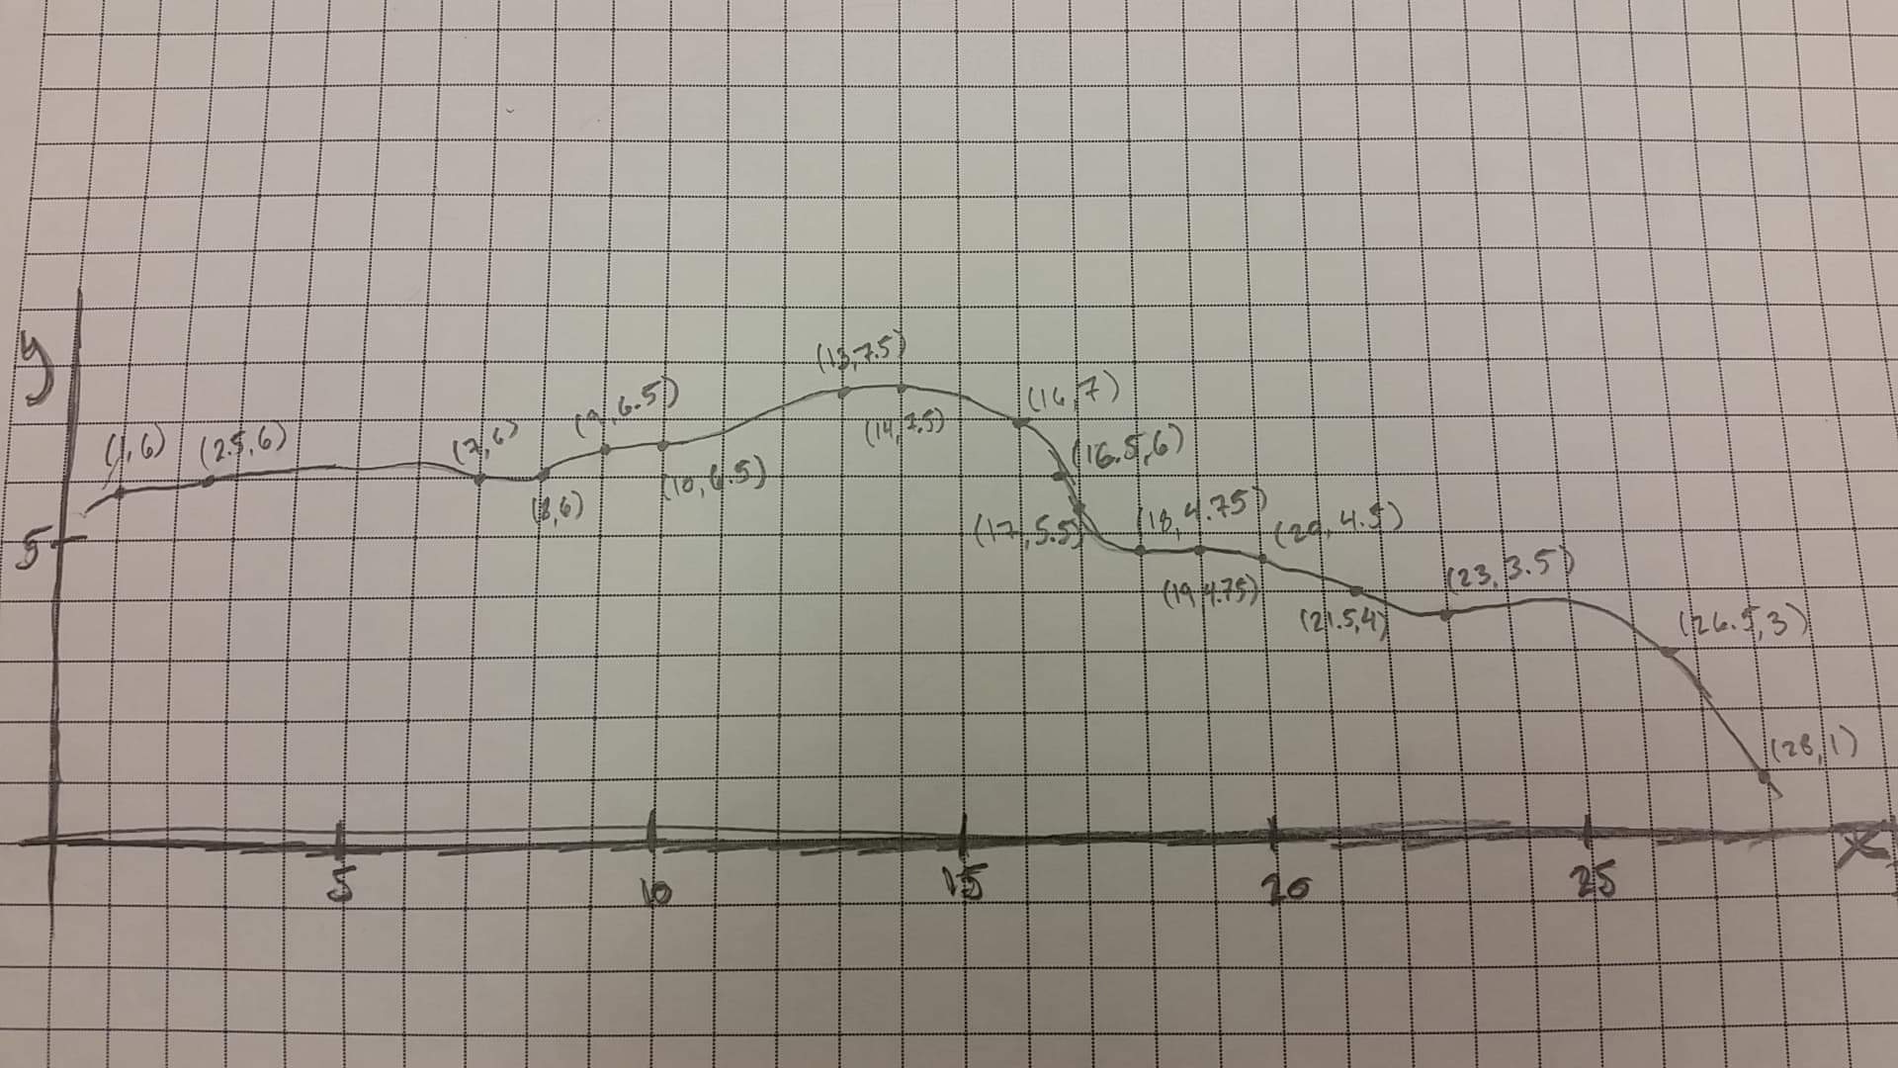

## Python

### Spyder Program

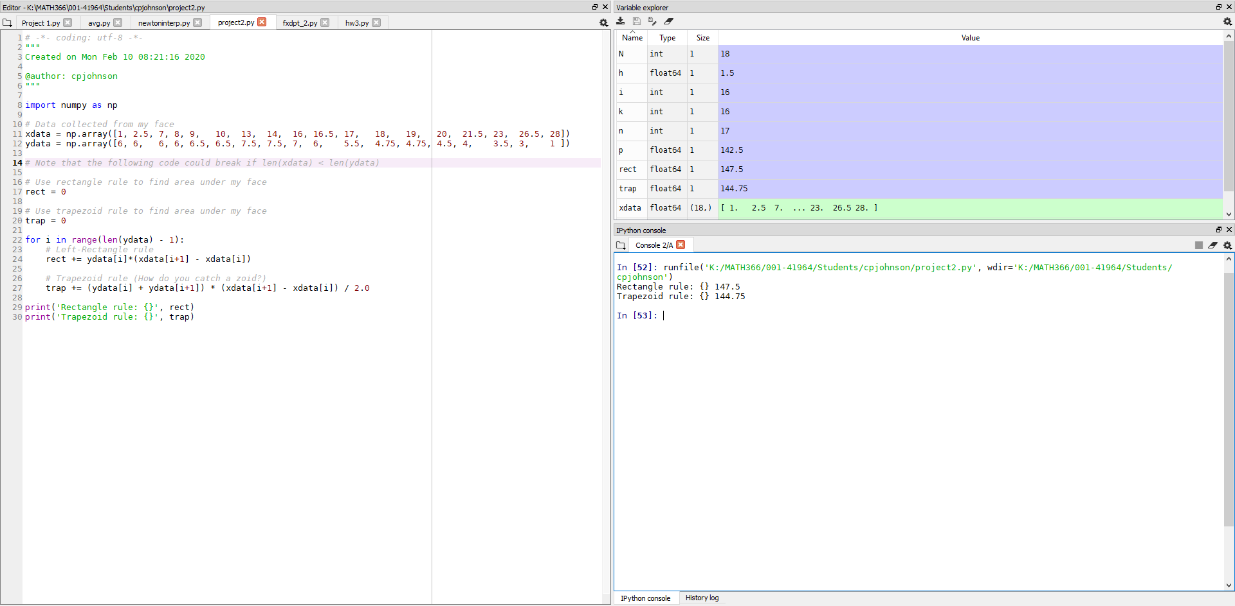

### Python Code

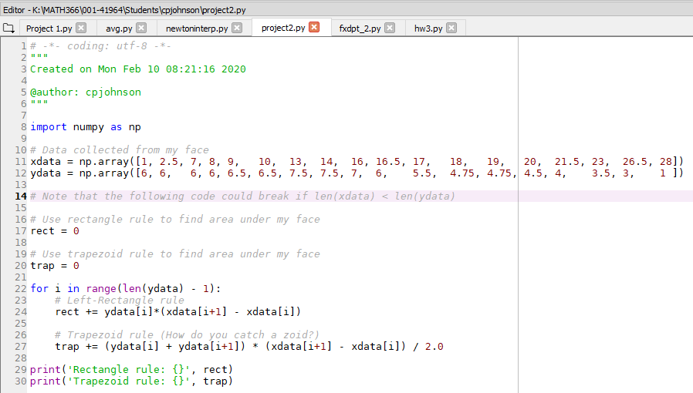

### Python Output

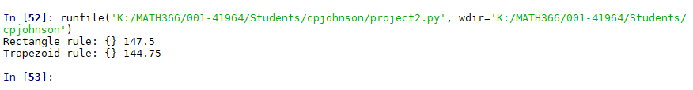

## MATLAB

### MATLAB Full

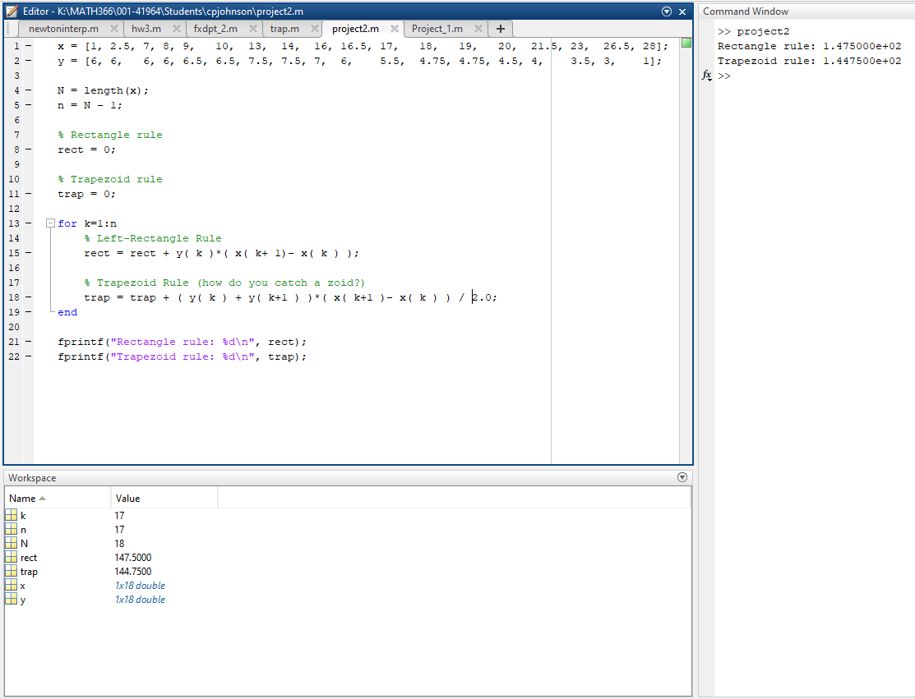

### MATLAB Code



### MATLAB Output

